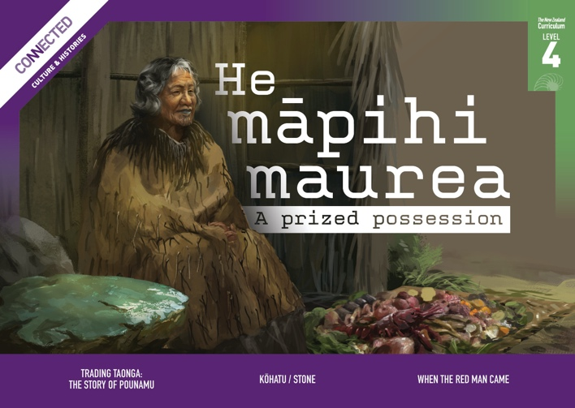


Level 4, 2022

Overview

This Level 4 Connected resource explores themes of economic opportunities, cultural redress through Treaty settlements, and mana taonga. It focuses on the cultural and economic significance of pounamu, locations and uses of stone resources in Aotearoa New Zealand, and the mana of a significant taonga pounamu, which is explored through a piece of historical fiction.
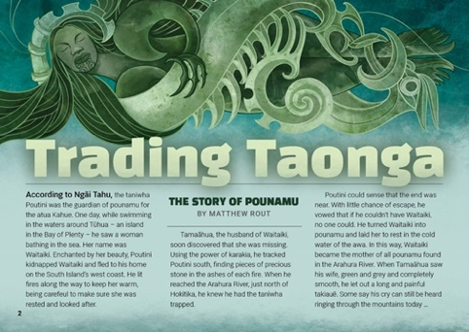  Trading Taonga:  The Story of Pounamu  by Matthew Rout (Ngāi Tahu)  Pounamu is a taonga with deep spiritual significance to Māori. Its beauty, usefulness, and cultural significance made it a highly prized resource that was traded throughout Aotearoa New Zealand. This article explores the pounamu trade from the 1770s through to the present day, discussing the impact of colonisation on the trade of pounamu and how Ngāi Tahu regained kaitiakitanga of pounamu through the Treaty settlement process.  The Google Slides version of this article has additional digital content to extend ākonga learning. | 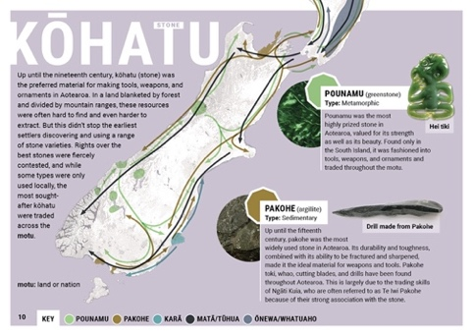  Kōhatu/Stone  (resource map)  This map provides information on significant trade routes in Aotearoa New Zealand, including materials that were traded, where they originated, and the locations of major trading centres. | 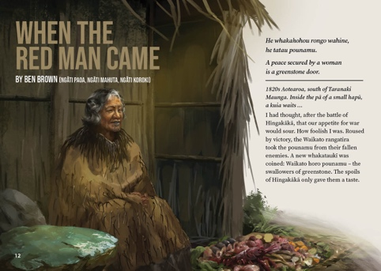  When the Red Man Came  by Ben Brown (Ngāti Paoa, Ngāti Mahuta, Ngāti Koroki)  This piece of historical fiction explores the significance of pounamu from a te ao Māori perspective. It has themes of whakapapa, mana, whanaungatanga, and utu. The story invites ākonga to consider how taonga can connect us to our histories and to each other.

Potential inquiry questions
- What role does mana play in political and economic relationships?
- How do economic opportunities enhance the mana of iwi and hapū?
- How have Crown actions impacted on Māori economic activity? How have iwi and hapū worked to reclaim and rebuild their economic base?
- How do significant taonga connect the past and the present?

ANZH curriculum overview (years 7–8)
  Understand  big ideas |   Know  contexts |  |   Do  inquiry practices
- Māori history is the foundational and continuous history of Aotearoa New Zealand.  - Colonisation and settlement have been central to Aotearoa New Zealand histories for the past two hundred years.  - The course of Aotearoa New Zealand’s histories has been shaped by the use of power.  - Relationships and connections between people and across boundaries have shaped the course of Aotearoa New Zealand’s histories. | Tūrangawaewae me te kaitiakitanga ǀ Place and Environment  Māori cared for and transformed te taiao and expressed their connection to places by naming the land and its features.  Kōwhiringa ohaoha me te whai oranga ǀ Economic activity  Iwi and hapū experimented with new economic opportunities to enhance their mana. In doing so, they built extensive trading networks domestically and with Australia. |  | When exploring these histories, I will be developing practices to:  - construct a narrative of cause and effect that shows relationships between events, identifying continuity or changes in the relationships and recognising that others might interpret these relationships differently  - use historical sources with differing perspectives on the past, giving deliberate attention to mātauranga Māori sources, and while doing so, recognising that the evidence available may not fully answer my questions and that my answers are themselves interpretations  - make an informed ethical judgment about people’s actions in the past, basing it on historical evidence and taking account of the attitudes and values of the times and the challenges people faced.
To find out more about the Understand, Know, Do framework, go to https://aotearoahistories.education.govt.nz/content-overview  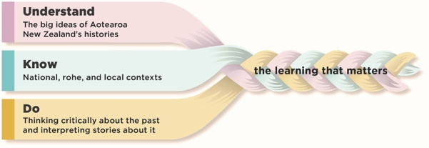
  Using this resource
  This resource provides examples of how you might use the three texts in this Connected to design learning experiences by weaving together the Understand, Know, Do elements of the Aotearoa New Zealand histories content.
  These activities are designed to build ākonga understanding of the practices that support them to think critically about the past and interpret stories about it. You can select from the activities depending on the needs of and relevance for your ākonga.
  The activities suggest ways ākonga can think critically about texts to build their knowledge and develop their understanding of the big ideas. They can help ākonga to understand that our knowledge of history comes from many sources including historical fiction, which uses real events as the basis for imaginative and interpretive explorations of history. The texts can contribute to ākonga-led inquiries into the stories told about the people, events, and changes that have been important in the local area.

Literacy skills at this level  Ākonga use a range of specific literacy skills to develop their understanding of history, engage with historical concepts, and communicate historical understandings.  - See the Literacy Learning Progressions: Meeting the Reading and Writing Demands of the Curriculum  - For significant signposts in reading and writing, see the Learning Progression Frameworks  - Note that for each text, there are links to the relevant aspect of the Learning Progression Frameworks (Reading).  When engaging with level 4 history texts, ākonga use their growing literacy expertise to:  - link multiple pieces of information across a text to identify cause and effect and continuity and change  - synthesise information to reflect critically on events and actions in the past  - interpret history-related terminology and concepts  - locate, evaluate, and compare relevant information from several sources  - explore a variety of perspectives  - formulate relevant questions for using history texts  - identify bias and stereotypes  - understand a writer’s point of view and how it has been deliberately conveyed using various language features and devices  - identify voices that are included and voices that are missing from a text  - apply knowledge of sentences to make sense of complex and or complicated sentences  - apply knowledge of text types and grammatical constructions to compare information  - use a range of connectives to keep track of ideas and information and make links across the text.  Depending on the needs and literacy expertise of your ākonga and the prior knowledge they bring, you may choose to share-read the texts with the whole class or small groups or use a mixture of guided and shared reading with specific groups. Alternatively, ākonga may be able to read the text independently or in pairs after an initial introduction from you. Audio can also be used for ākonga who require more support and who would benefit from rereading the text. | Other strategies such as jigsaw or reciprocal reading may be helpful for particular texts. It may also be helpful to have ākonga preview the text, noting particular features and making predictions about the content and purpose. Before reading, you may decide to explore with ākonga some of the specialised vocabulary, te reo Māori, place names, or words and phrases that are not explained by the context or the glossary.  Activating prior knowledge  Before reading a story or article, activate the prior knowledge of ākonga to help them fully engage with the text. There are many ways you might do this. For example:  - Share a key image on a screen and have ākonga discuss what it shows (what, when, where, why, and who).  - Devise a questionnaire on a relevant topic you are focusing on in the text. Have ākonga discuss their answers in pairs and then share with the class. Create a class chart of current knowledge that can be challenged, changed, or confirmed throughout the inquiry.  - Have ākonga begin a KWLQ chart and complete the chart when they finish the text.  Prompt ākonga to share ways that historians might approach a source, for example, by asking questions about its purpose, audience, perspective, and relationship to other sources. The National Library provides a useful tool for evaluating primary sources.
  The Refresh of the New Zealand Curriculum is replacing the Learning Progression Frameworks and Literacy Learning Progressions by incorporating the learning for literacy & communication into the curriculum learning area progressions. To learn more about the refresh visit Refreshing The New Zealand Curriculum.
  Connecting with your local histories
  - Explore iwi connections to resources that were useful or valued in your rohe, along with pūrākau and whakataukī that relate to them.
  - Explore the roles mana whenua play as kaitiaki of taonga in your rohe.
  - Visit a local museum or heritage site and learn about the ways mana taonga is acknowledged by the institution.
  - For guidance on exploring the Māori history of your rohe, see pages 3–4 of Te Takanga o te Wā – Māori history guidelines for years 1–8 and ANZH Leading Local Curriculum Guide – Part 1.
  Your ākonga bring their own perspectives and experiences to these histories. They may have personal and emotional connections with and reactions to some of the histories. Be aware of this in your planning and use the critical inquiry practices to support respectful conversations. (See also Leading Local Curriculum Guide – Part 2 and content on the Aotearoa New Zealand’s Histories website.)

Trading Taonga: The Story of Pounamu  by Matthew Rout (Ngāi Tahu)  The Google Slides version of this article has additional digital content to extend ākonga learning. | Key concepts  Iwi and hapū experimented with new economic opportunities to enhance their mana. In doing so, they built extensive trading networks.  Mana was central to all political and economic relationships in traditional Māori society and has continued to shape internal and external interactions. | Author biography  Matthew Rout is a Senior Research Fellow at the University of Canterbury Ngāi Tahu Research Centre. He also co-authored Tribal economies – Ngāi Tahu: an examination of the historic and current tītī and pounamu economic frameworks. | 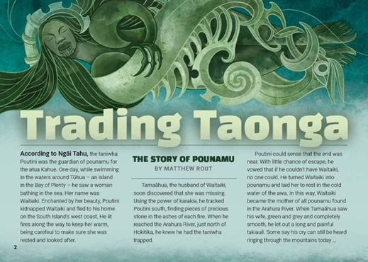

Literacy demands of the text
This text has links to the following aspects of the Learning Progression Frameworks (Reading):
- Making sense of text: using knowledge of text structure and features
- Reading to organise ideas and information for learning
- Acquiring and using information and ideas in informational texts.
The signposts on each of these aspects provide detail about what to notice as your ākonga develop their literacy knowledge and skills for different purposes in different curriculum areas. The text also provides opportunities for ākonga to develop and use the knowledge and skills outlined in the Literacy Learning Progressions “by the end of year 8”.
This text requires ākonga to synthesise information from different text types, including the narrative story, explanations, descriptions, and text box, to understand the importance of pounamu. They will need to negotiate a number of complex sentences to find details and important information to build knowledge as they read the article. You could provide ākonga with a strong introduction to the text and remind them to look for the main ideas and details as they read. Ākonga could turn the subheadings into questions to help them focus on specific ideas and details.
Another literacy demand lies in the use of topic-specific and specialised language and te reo Māori. Some of this language has been glossed, but many meanings can be worked out by using context and sentence structure.

Connecting with your local histories
Explore iwi connections to resources that were useful or valued in your rohe, along with pūrākau and whakataukī that relate to them.
Learn about Treaty settlements in your rohe, including recognition of mana whenua as kaitiaki of different taonga.
For guidance on exploring the Māori history of your rohe, see pages 3–4 of Te Takanga o te Wā – Māori History Guidelines for Years 1–8 and ANZH Leading Local Curriculum Guide – Part 1.

Background information for kaiako
- Learn more about Ngāi Tahu, the return of ownership of pounamu, and the Ngai Tahu Pounamu Management Plan.
- Te Ara provides a summary of Ngāi Tahu tribal affiliations and migration to Te Waipounamu.
- Pounamu – Jade or Greenstone – Te Ara Encyclopedia of New Zealand
- Poutini: A Guardian Taniwha – Toitū Te Whenua Land Information New Zealand
- This episode of RNZ’s Aotearoa History show, Māori: The First 500 years, provides supporting information about pounamu as a symbol of mana.

Related text
- “Keeping Promises: The Treaty Settlement Process” – School Journal Level 4, November 2017

Big ideas
The following activities all support understanding the four big ideas: Māori history, colonisation and settlement, the use of power, and relationships. For example:
- Pounamu was a driving force of a sophisticated pre-European Māori economy and was exchanged for a range of goods and services.
- The trade and gifting of pounamu taonga was a basis for long-lasting social connections between iwi and hapū.
- Pūrākau are one way that the significance of pounamu for Ngāi Tahu and other iwi and hapū is expressed. Taonga pounamu can carry stories of important tūpuna and relationships between iwi and hapū.
- The Crown’s purchase of much of Te Waipounamu from Ngāi Tahu, and the resulting loss of Ngāi Tahu access to and kaitiakitanga of pounamu, had huge economic and cultural consequences for the iwi and its mana.
- The return of pounamu to Ngāi Tahu via the Treaty settlement process has helped to restore the mana and the cultural and economic independence of the iwi.

Activities

The origins of pounamu
In this activity, ākonga use a pūrākau about the origins of pounamu as a historical source to build knowledge about ways that Māori expressed their connections to places by naming the land and its features.
Display the first page of the article, explaining that the article is about the trading of pounamu. Point out that the writer of the article is from Ngāi Tahu and, if ākonga are not familiar with this iwi, explain that the whenua of Ngāi Tahu covers much of Te Waipounamu (the South Island) and is the country’s largest tribal territory.
Have ākonga work in pairs or small groups to brainstorm what they already know about pounamu, for example, its uses, where it is found, whakataukī related to it, and why it holds a special place in Ngāi Tahu and Māori culture.
Read the story of the taniwha Poutini and ask ākonga to think-pair-share why the article begins with this pūrākau, for example:
- What role do you think this pūrākau plays in the article?
- What connections does the pūrākau make between ngā atua, humans, and the natural world?
- How does the pūrākau show that pounamu is a highly valued stone?
- Why might there be different interpretations of this pūrākau?
Locate each of the places mentioned in the pūrākau on a map of Aotearoa. Explain that the Ngāi Tahu name for the West Coast is Te Tai o Poutini and that the tangata whenua of the West Coast are called Poutini Ngāi Tahu. See page 7 of this TSM for another activity related to names in the Poutini pūrākau.
Use the He Tohu video He Whenua Rangatira to show that Ngāi Tahu migrated from the East Coast of Te Ika a Māui to Te Waipounamu, making connections with the journey Tamaāhua made from Tūhua to the Arahura river. Note that the migrations of Ngāti Whairaki (an iwi mentioned on page 5 of the article) are also depicted on this map using the label Ngāti Whairangi.
Have ākonga work together to create a comic-style illustration of the pūrākau to display on the classroom wall. Encourage them to include a map that shows where pounamu is found.

Trading Taonga: The Story of Pounamu

The value and mana of pounamu
In this activity, ākonga identify continuity and change in terms of the ways pounamu has been used and valued over time.
Using information in the article, have ākonga identify reasons for pounamu being such a highly valued stone, both in the past and today, using a mind-map to record examples related to its:
- properties
- practical uses
- availability/scarcity
- symbolic or cultural importance
- economic benefits.
Ākonga may like to colour-code the examples based on whether they are related to the past, the present, or both.
Show ākonga the kōhatu infographic on pages 10 and 11 of Connected and ask them to use examples in their mind map to justify the statement in the infographic that pounamu was “the most prized stone in Aotearoa”.

Pounamu and social relationships
In this activity, ākonga explore the relationship between the pounamu trade and the building of social relationships.
Reread the information about the trade networks and traditional Māori economy on pages 6 and 7 of the article and watch the following excerpts from the RNZ Aotearoa History Show episode Māori: The first 500 years:
- 3:02–7:52
- 17:39–20:13.
Using information in the texts and the video, ask ākonga to think-pair-share:
- How might the pounamu trade have strengthened relationships within Ngāi Tahu hapū and iwi? What roles and responsibilities did it create?
- How did the pounamu trade enhance the mana of Ngāi Tahu? What benefits did it bring?
- How did trade in pounamu strengthen social relationships with other hapū and iwi? How were these social relationships maintained?
Read the Connected story “When the Red Man Came” and discuss the role gifting taonga pounamu could play in terms of restoring balance between warring parties. Additional information about the relationship between pounamu and peacemaking is available on Te Ara Encyclopedia of New Zealand. Ask ākonga to create a poster illustrating the metaphor of a tatau pounamu (greenstone door) symbolising an enduring peace agreement.

Kaitiakitanga or control of pounamu
In this activity, ākonga explore the cause and effect relationships related to control (or loss of control) over access to pounamu.
Ask ākonga to locate examples in the article of kaitiakitanga or control over pounamu changing over time.
Using information on page 8 (under the heading “The loss of pounamu”), ask ākonga to create a multi-flow map showing the causes and effects of Poutini Ngāi Tahu losing all control over their taonga.
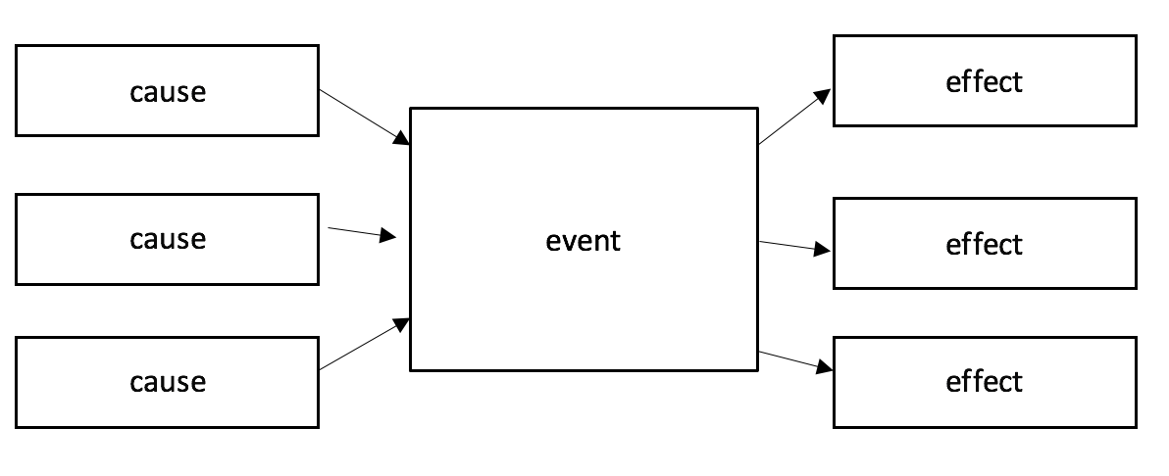
Follow this by asking ākonga to create a parallel map showing the causes and effects of Ngāi Tahu regaining kaitiakitanga of pounamu using the information on page 9.

Kōhatu/Stone  (resource map) | Key concepts  Iwi and hapū experimented with new economic opportunities to enhance their mana. In doing so, they built extensive trading networks. | 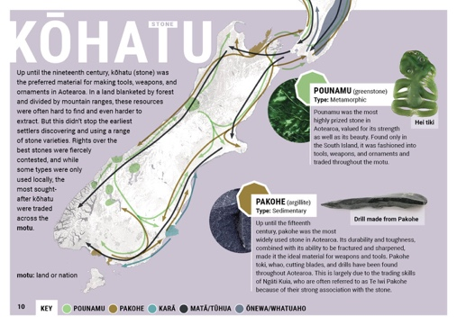

Literacy demands of the text
This text has links to the following aspects of the Learning Progression Frameworks (Reading):
- Making sense of text: using knowledge of text structure and features
- Making sense of text: vocabulary knowledge
- Reading to organise ideas and information for learning
- Acquiring and using information and ideas from informational texts.
The signposts on each of these aspects provide detail about what to notice as your ākonga s develop their literacy knowledge and skills for different purposes in different curriculum areas. The text also provides opportunities for ākonga to develop and use the knowledge and skills outlined in the Literacy Learning Progressions “by the end of year 8”.
The main literacy demands for ākonga are the technical information and vocabulary about different stone types. It may be helpful for ākonga to explore the technical and topic-specific vocabulary before reading.
Groups or pairs of ākonga could research the meanings of several words to share with the whole class. You could also remind ākonga of strategies for working out the meanings of words as they read by using word knowledge, structure, and context.
It may be helpful to pose the following questions, or have ākonga ask their own questions, as they discuss and interpret the meaning of the infographic:
- What is the purpose of this infographic? What are the big ideas it is conveying? What helps you to know that?
- Where do we start reading? Does it matter where we start?
- What are the parts of the infographic? What information do they contain? How do they work together as a whole?
- What information has been left out? What doesn’t the infographic show?
- Who might have created this infographic, and who was it created for?
- Why do you think the information was presented this way? How effective is this way of presenting information?
- What can we learn about different types of stone and their uses from this infographic?

Connecting with your local histories
Identify which stone resources may have been significant in your rohe.
If possible, visit a local museum that has examples of tools, weapons, or ornaments made from different kinds of stone. Ask the museum educator why these artefacts are considered important, how they are looked after, and what is known about their whakapapa.

Background information for kaiako
- Kōhatu – Māori Use of Stone – Te Ara Encyclopedia of New Zealand
- Poutini: A Guardian Taniwha – Toitū Te Whenua Land Information New Zealand

Related text
Connected Level 4, 2019, “The Long Pause” – Google Slides version (slide 14, Toʻi Maʻa/Adze)

Big ideas
The following activities all support understanding the four big ideas: Māori history, colonisation and settlement, the use of power, and relationships. For example:
- Māori use of stone – particularly of pounamu – required the development of new technologies for working the stone into useful tools and beautiful ornaments.
- Māori oral histories are a way that the locations of certain types of stone and the methods and tikanga for working stone are passed on.
- Some iwi are kaitiaki of certain types of stone in their rohe.
- Stone was often a basis for relationships between iwi and hapū in the form of trade, and sometimes in the form of conflict over the rights to the stone.

Kōhatu/Stone

Activities

Visual dictionary of kōhatu
In this activity, ākonga compare the uses of different kōhatu in Aotearoa New Zealand, making connections between their properties, uses, and availability.
Encourage ākonga to look up the meaning of any unfamiliar terms in the infographic.
Using information in the infographic and other research, ask ākonga to complete a table summarising key information about the different types of stone, for example:
Stone
Location(s) of sources
Properties
Use(s)
Associations
with iwi/hapū
Other information or questions

Have ākonga create a visual dictionary for reference, including sourcing images of different tools, weapons and ornaments made from each stone. Ask ākonga to explain the relationship between the properties of a kōhatu and its uses.

Oral map of sources of kōhatu
In this activity, ākonga make connections between sources of stones identified in the text and places mentioned in a pūrākau about Poutini on the Toitū te Whenua Land Information New Zealand (LINZ) website. LINZ describes the story as an 'oral map of the ancient quarries from which the tūpuna took their valued stones', with the names of several key sites integrated into the pūrākau. The LINZ web page includes a summary table of place names mentioned in the story and the stone resources found at them.
Read the pūrākau of Poutini – A Guardian Taniwha on the LINZ website and show ākonga the table at the bottom of the webpage that summarises connections between locations and sources of stone.
Working together and using a digital map for support, ask ākonga to locate each of the places named in the pūrākau on their own map, adding the names of places to the map. Ākonga will need to connect information in the table on the LINZ webpage with the corresponding te reo Māori names of sources used in the infographic. Discuss other ways that pūrākau can be used to pass on valued knowledge.

Kōhatu in a changing world
In this activity, ākonga consider the relationship between access to kōhatu and societal change.
Ask ākonga to think-pair-share why sources of kōhatu were so important for the earliest settlers of Aotearoa New Zealand.
Watch the following excerpts from the RNZ Aotearoa History Show episode Māori: The first 500 years:
- 3:02–7:52
- 17:39–20:13.
Drawing on information in the video and infographic, ask ākonga to consider:
- why pakohe (argillite) was so widely used up until the fifteenth century
- why pounamu is described in the infographic as the most highly prized stone in Aotearoa
- evidence that access to resources such as matā/tūhua were both contested and protected.
Ask ākonga to think-pair-share what changes occurred in the nineteenth century that reduced the preference for kōhatu as a material for making tools, weapons, and ornaments.

When the Red Man Came  by Ben Brown (Ngāti Paoa, Ngāti Mahuta, Ngāti Karokī) | Key concepts  History is more than a sequence of recorded events. This piece will help ākonga connect with the more subtle elements of our past by exploring the spiritual significance of pounamu from a te ao Māori perspective. It will inspire ākonga to think more deeply and critically about the meaning of whakapapa and whanaungatanga and to consider how taonga can connect us to our histories and to each other.  Mana was central to all political and economic relationships in traditional Māori society and has continued to shape internal and external interactions. | Author biography  Ben Brown is an award-winning children’s author, poet, and writer. In 2021, he became the first Te Awhi Rito New Zealand Reading Ambassador, a role overseen by the National Library to champion reading, literature, and literacy in the lives of young Kiwis, their whānau, and communities. | 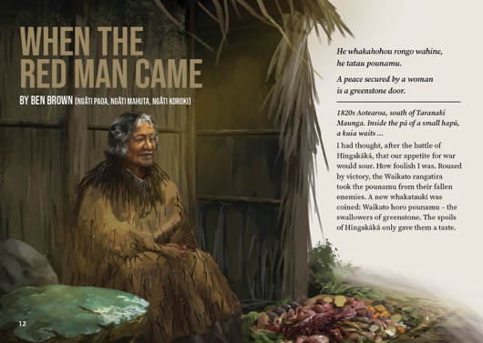

Literacy demands of the text
This text has links to the following aspects of the Learning Progression Frameworks (Reading):
- Making sense of text: vocabulary knowledge
- Making sense of text: reading critically
- Reading for literary experience.
The signposts on each of these aspects provide detailed illustrations on what to notice as your ākonga develop their literacy knowledge and skills for different purposes in different curriculum areas. The text also provides opportunities for ākonga to develop and use the knowledge and skills outlined in the Literacy Learning Progressions “by the end of year 8”.
The key literacy demand for ākonga lies in the use of metaphor and other literary devices to tell the story from the perspective of the kuia. Ākonga will need to draw on their knowledge of figurative language, make inferences, and use the sequence of the kuia’s internal dialogue to follow the building tension and recognise her intentions.

The kuia gives her thoughts, feelings, and opinions, and ākonga will need to distinguish between her reflections on past events and her observations of the present. The writer uses a literary style rich with metaphor and that reflects how language was sometimes used in the past, and this too may be challenging for some ākonga. It could be useful to unpack some sections of text with ākonga and have them discuss, explore, and evaluate the ways in which language has been used and its meaning.
After reading, you could have ākonga retell the story in pairs and notice any places where clarification or additional information is required.
At the end of the narrative is an explanation of the true events surrounding the story. It could be useful for ākonga to read this section first to understand the context surrounding the story.

Connecting with your local histories
Investigate whether there were any historical battles fought in your rohe, and research the consequences of these, for example, in terms of the movement of people.

Background information for kaiako
- Te Wherowhero – Part 1: Hīngakākā – RNZ
- A graphic novel about the Battle of Hīngakākā.

Big ideas
The following activities all support understanding the four big ideas: Māori history, colonisation and settlement, the use of power, and relationships – for example:
- Conflicts between iwi and hapū were sometimes settled by the gifting of mana taonga such as pounamu.
- Mana is enduring and inherited and, as such, future generations have a responsibility to restore mana diminished by the actions of previous generations.

Activities

Understanding the text
In this activity, ākonga use a three-level guide to explore the story in depth and then generate their own questions about historical events or ideas mentioned in the text. Adapt the statements to suit the needs of your ākonga. Have them share their responses in pairs or groups before discussing as a class.

Level 1: Understanding what is happening
- Tiri-a-Ngahue (the pounamu) has been in the care of the kuia’s whānau for a very long time.

When the Red Man Came
- Te Wherowhero is travelling alone.
- The kuia is hoping to end the conflict between her people and Te Wherowhero.

Level 2: Reading between the lines (understanding what is implied by the text)
- Both the kuia and Te Wherowhero come from chiefly lines.
- Te Wherowhero is coming to claim a stolen pounamu.
- Te Wherowhero fought at the battle of Hīngakākā.
- The kuia is willing to risk her life to save her people.
Level 3: Thinking beyond the text (talking about the issues related to the text)
There isn’t necessarily a right or wrong answer for these statements – the point is to debate both sides.
- When a wrong has been done in the past, the generations that follow have a responsibility to resolve it.
- An act of peace is more powerful and long lasting than an act of war.
- A single powerful act can be a turning point in how a conflict unfolds.
Ask ākonga to reread the text and develop a set of questions about events or ideas related to the text. These can be used as the basis of an inquiry. In cases where it is hard for ākonga to locate relevant information to answer their questions, discuss the reasons for this, for example, one of the impacts of colonisation is that that some oral histories have been lost.

Mana taonga
In this activity, ākonga deepen their understanding of Māori history by exploring the cultural values, tikanga, and knowledge relating to the taonga pounamu described in the story.
Explain that museums, such as Museum of New Zealand Te Papa Tongarewa (Te Papa), are guided by the principle of mana taonga, and ask ākonga to share their ideas about what this might mean. On its website, Te Papa describes this as the recognition of the power of taonga to “communicate deep truths about our people”.
Create a wheel using aspects of mana taonga (source: Te Papa) and have ākonga identify examples from the text of:
- the importance of taonga
- the tapu of taonga
- the resonance of taonga (power to evoke memories, emotions)
- the spirituality of taonga
- the influence of taonga (the ways taonga can shape relationships and influence decisions).

Writing historical fiction
In this activity, ākonga deepen their understanding of Māori history by exploring which aspects of this story are known and which aspects may be a product of “historical imagination”.
In groups, ask ākonga to create a table with three columns, one headed “Known details”, one “Imagined details”, and the third “Unsure”. Ask them to reread the story, writing details from the story into the appropriate column. The section “War and peace” could help them, and they might also like to research the events described or alluded to in the story.
When ākonga have completed this task, groups could share their tables and compare which parts they thought were known details and which were imagined. Ask groups to discuss:
- How might writers use other information to help them fill in gaps when writing a story?
- What are the strengths and weaknesses of using imagination when writing historical fiction?

