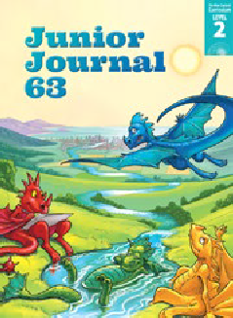Kūmara – Behind the Scenes
by Trish Puharich
Junior Journaal 63
Level 2
Purple 1

The Learning Progression Frameworks (LPFs) describe significant signposts in reading and writing as ākonga develop and apply their literacy knowledge and skills with increasing expertise from school entry to the end of year 10. This teacher support material describes the opportunities in “Kūmara – Behind the Scenes” for ākonga to develop this expertise.

Overview

This report uses text and flow charts to describe the many steps and people involved in getting products, in this case kūmara, to the supermarket. It provides opportunities to think critically about the people and systems supporting communities, often behind the scenes. Like “Volunteers” in this journal, it can also be used to
explore the theme of mahi tahi – working together for a common goal. “Kūmara – Behind the Scenes” is accompanied by a recipe for kūmara wedges, which can be used by ākonga with adult supervision.

LPFs | Curriculum links
- Making sense of text: using knowledge of text structure and features  - Making sense of text: vocabulary knowledge  - Acquiring and using information and ideas in informational texts | - English  - Social Sciences  - Technology

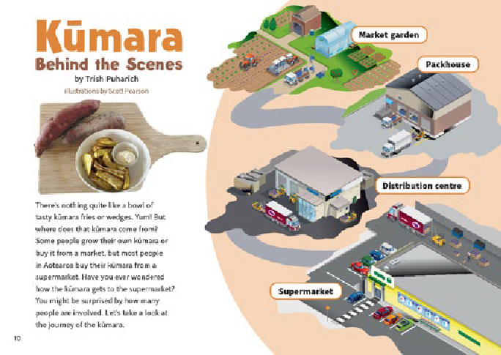Key text features
The New Zealand Curriculum
“Kūmara – Behind the Scenes” includes the following characteristics that help ākonga develop the reading behaviours expected at Purple and build their awareness of the features of different text forms.

The structure of the text as a report, with an introduction, a description of steps in a process, and a conclusion

Layout features typical of non-fiction: headings, diagrams (in this case, flow charts), labels, definitions, and bullet points

Language features that enable ākonga to apply and extend their vocabulary knowledge:
- the figure of speech “behind the scenes”
- the use of the present tense in the flow charts
- noun phrases (for example, “market garden”, “office workers”, “distribution centres”, “household products”, “storage area”)
- topic-specific terms, some appearing in more than one form (“packhouse”, “packed”; “stored”, “storage”; “distribution”, “delivers”, “receive”, “collect”)

Some possibly unfamiliar words and phrases (for example, “behind the scenes”, “tasty”, “wedges”, “involved”, “journey”, “packhouse”, “distribution”, “vegetables”, “crates”, “pallets”, “products”, “delivers”, “receive”, “customers”, “storage”, “collect”, “shelves”, “recipe”, “medium-sized”, “curry powder”, “hummus”, “preheat”, “200 degrees Celsius”, “serve”) requiring ākonga to use their processing systems

Sounds and Words
Related Texts

Texts that describe a process: Bread (RTR shared); “Making a Road” (JJ 50); “Pop! Froth! Fizz!” (How Do You Know? Connected L2 2014); “Fingerprints” (JJ 54); “Beach Buddy” (JJ 60); “Investigating Magnets”, “Let’s Race” (JJ 61); “Making a Sign” (JJ 62)
Texts about people or services that support communities: Isobel’s Garden (RTR Turquoise); Duckling Palace, Guide Dogs (RTR Purple); “The Port” (JJ 47); “Making a Road” (JJ 50); “Getting the Message Across” (JJ 62)

Possible reading purposes | Possible learning goals
What can ākonga expect to find out or think about as a result of reading this text?  - To find out how kūmara gets to the supermarket  - To think about how people work “behind the scenes” in communities | What opportunities does this text provide for ākonga to learn more about how to “read, respond to, and think critically” about texts?  This text provides opportunities for ākonga, over several readings, to:  - use information in the text and visual language features to track and clarify the process  (summarise)  - make connections between their prior knowledge and information in the article to  ask questions and look for or think about possible answers  - make connections between information in the article and their prior knowledge to  make inferences  - identify and discuss main ideas about people who work “behind the scenes”  - monitor their reading and, when something is unclear, take action to solve the problem.

The Literacy Learning Progressions

Introducing the article
Use your knowledge of your ākonga to ensure that your introduction to the article builds or activates their prior knowledge and provides appropriate support for a successful first reading. Several options are provided below for you to select from and adapt. A short video on the importance of introducing the text is available at https://vimeo.com/142446572  For English language learners, before the whole-group session, you could use a selection of photographs to introduce some of the topic vocabulary in the article, such as,  “vegetables”, “bins”, “pallets”, and “trucks”. You can find further information about features of texts that may need support at ELLP.  - Show ākonga the recipe on page 17 and ask them to share their experiences of eating, growing, and buying kūmara.  - Return to page 10 and read the title. What does it mean to do things “behind the scenes”?  - Read page 10 together to establish the purpose of the article and what ākonga will find out. | - Discuss the “journey of the kūmara” as summarised on page  11. Introduce the term “flow chart” and explain that it shows the sequence of steps in a process (in this case, the process of getting kūmara to the supermarket). Draw attention to the grey “pathways” linking the four key locations. Make connections to other flow charts known to ākonga, for example, pages 6–7 of the shared book Bread.  - Write the page 11 labels on a chart and record ākonga ideas (predictions) about their meanings and what might happen in each place. Remind them to look for more information when they read the text.  - Briefly discuss the format of pages 12–15 and how the headings match the labels on page 11. Track how the grey lines, pictures, and bullet points describe the journey of the kūmara in more detail.  - Together, set the reading purpose (To find out …). This TSM suggests an initial “To find out” purpose to build background knowledge, followed by a deeper purpose (“To think about …”).  - Give ākonga sticky notes to mark aspects they might want to return to or discuss later.

Reading the article
Encourage ākonga to read the article by themselves, intervening only if needed. Much of the processing ākonga do at this level is “inside their heads” and may not be obvious until the discussion afterwards. The focus of the first reading is for ākonga to identify key information and ideas relevant to the initial reading purpose. Allow for several sessions to read and discuss the text, to investigate other reading purposes, and explore ideas and language features more deeply.
Reading behaviours to look for
Examples of the sorts of behaviours (often overlapping and developed over several readings) that will support ākonga to meet the reading purpose(s)
Ākonga use information in the text and visual language features to track and clarify the process.  - They use the definitions together with the illustrations to clarify their understanding of the headings on pages 12–15.  - They use the headings to clarify the focus of each section and the grey “pathway” to track the connections between the sections.  - They look for key words to indicate information that supports the reading purpose.  They make connections between information in the article and their prior knowledge to make inferences.  - They make connections to their own experiences of supermarket shopping and infer that without all these people and processes, customers would not be able to buy what they need.  - They notice the word “products” rather than “kūmara” on page 14 and use this to infer that a distribution centre sends many different types of products to supermarkets.  - They infer from the fact that kūmara often arrive when there are no customers and that truck drivers often work at night. | They make connections between their prior knowledge and information in the article to ask questions and look for or think about possible answers.  - They use their sticky notes to record questions (and possibly, answers) and ideas. For example, they might wonder:  ‒ how large a market garden might be  ‒ what the process might be like for other foods  ‒ about people they know who are involved in similar work.  They demonstrate self-monitoring and problem solving.  - They use a range of word-solving strategies. For example, they:  ‒ break words into chunks or syllables and rerun the phrase or sentence to check it makes sense  ‒ read on to get the full meaning of noun phrases  ‒ use the context of the sentence and search for information in the illustrations to support the meaning of “crates” and “pallets”.  - They mark words, phrases, and ideas they want to come back to.  You can find further information about the reading behaviours that English Language Learners need to develop proficiency with at this stage, on the ELLP Pathway.
Deliberate acts of teaching
How you can support individual ākonga (if needed)
- Prompt them to use the illustrations and text together to clarify word meanings and the sequence of events.
- Remind ākonga of strategies they can use for word solving (for example, looking for the biggest known word chunk; applying their knowledge of letters, sounds, and word structure) and for clarifying meaning (rereading or reading on, referring to the flow charts, and thinking about the overall meaning of the sentence).
Thinking, talking, rereading
You can revisit this text several times, providing opportunities for ākonga to build comprehension, vocabulary, and fluency. Select from and adapt the following suggestions. Some overlap, and several can be explored further as after-reading activities. For some suggestions, you may find it helpful to project the PDF of the article so that you can zoom in on relevant sections.
- Invite ākonga to share their initial responses and any connections they have to people who work in similar roles.
- Remind ākonga of the initial reading purpose. Reread the text together, summarising the steps in the process on a table such as the one below. You could do one of the sections together, demonstrating how to write notes or bullet points rather than full sentences, and then have ākonga work in pairs to complete one section each.
Where | Who | What
Market garden
Packhouse
Distribution centre
Supermarket

- Discuss any new questions or ideas arising from their sticky notes. Plan for ways ākonga can follow up on aspects of particular interest.
- Refer to the labels written on the chart you created when introducing the text and, together, add definitions.
- Make connections to what ākonga know about gardening, for example, the times of the year when certain crops are planted and harvested, Tikanga a Rongo-te mara (traditional Māori gardening practices and cycles), or the connection to Matariki (a traditional time where kūmara are planted). As an extension, you could investigate Pataka kai, traditional Māori food storage, preservation, and practices.
- Explore main ideas about the networks within communities. Prompt ākonga to think critically, making connections between the article and their own experiences. for example:
‒ Discuss the concept of mahi tahi – working together for a common goal (in this case, getting the kūmara to the supermarket). Support ākonga to think of other examples of getting products to the supermarket or of other community services. Alternatively, you could focus on people in the community who help others (shopkeepers, drivers, gardeners, office workers, volunteers, teachers, builders, doctors, and so on). Why is mahi tahi important to communities?
‒ Support ākonga to consider how other people work “behind the scenes” to help processes, organisations, or events run smoothly. Choose a process that is familiar to ākonga (for example, organising a birthday party, getting ready for school or sports, or putting on a school concert). Talk together about who is involved, what needs to happen, and how people often work “behind the scenes” to make things happen. Create a simple flow chart template to record three or four steps.
‒ Make connections to other JJ 63 texts ākonga have read. For example: The author of “Volunteers” writes that the volunteers are “doing great things to make Aotearoa New Zealand a better place to live.” How are the workers involved in “the journey of the kūmara” making our lives better? What would it mean for us if they did not do these things?
Building language knowledge
As ākonga reread and discuss the article, note opportunities for explicit instruction and to explore language features in more detail. For example:
- how ākonga worked out new vocabulary (or tried to). You could clarify the pronunciation of “pallets” (pal-lets rather than pall-ets) and “shelves” as the plural of “shelf”.
- the topic-specific vocabulary. Reread the sentences where the words occur to clarify their meanings. You could choose some to explore further, for example, by identifying the root word and then adding to it to create other words (packhouse – pack, packing, packet, backpack; storage – store, stored, storing, storeroom; distribution – distribute, distributed, distributor; products – product, production, produce; deliver – delivered, delivery; collect – collecting, collector, collection).
- the noun phrases and how the first word in the phrase provides specific information (“market garden”, “office workers”, “distribution centres”, “household products”, “storage area”).

- Ākonga can build their comprehension and fluency by listening to the audio version as they reread the article.

Audio versions are particularly supportive for English language learners because, as well as clarifying pronunciation, they provide good models of the prosodic features of English, such as intonation and phrasing.

- Encourage ākonga to share (or find out more) about people they know who work behind the scenes for the community.
- Arrange for ākonga to try out the recipe at home or school.
- Ākonga could work in pairs to create their own flow chart of a familiar process or of the steps in the recipe for making kūmara wedges.
- Alternatively, support ākonga, working in pairs or small groups, to research the journey of another product to the supermarket and create their own flow charts of the process.
- Follow up on the discussion after reading by having ākonga write about people in the community who help others – what they do and why their work is important.
- Provide opportunities for ākonga to find out more about any other aspects of this article that sparked their curiosity.

For English language learners, SELLIPS and the Teaching Strategies section of ESOL Online also have ideas for purposeful and relevant tasks.




ISBN 978-1-77690-607-9 (PDF)
ISBN 978-1-77690-763-2 (WORD)

