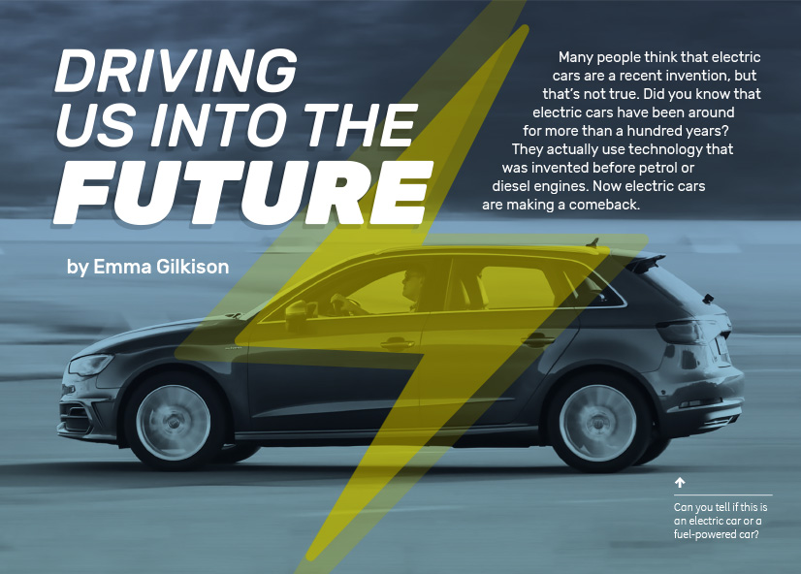
Connected
Level 4
2016

Driving Us into the Future
by Emma Gilkison

Overview
This article describes the development of electric cars and contrasts this with the development of cars using diesel and electric engines. It compares the technology they employ and the impact they have on the environment. Readers are invited to speculate on what the future may bring as we seek to maintain the convenience of motorised transport while reducing its impact on the environment.
A Google Slides version of this article is available at www.connected.tki.org.nz.

Curriculum contexts

TECHNOLOGY: Nature of Technology: Characteristics of technology  Level 4 – Understand how technological development expands human possibilities and how technology draws on knowledge from a wide range of disciplines.  TECHNOLOGY: Nature of Technology: Characteristics of technological outcomes  Level 4 – Understand that technological outcomes can be interpreted in terms of how they might be used and by whom and that each has a proper function as well as possible alternative functions. | Key technology ideas  - Science and technology together produce a range of possible solutions for a specific need or opportunity.  - We use a wide variety of technologies to harness and transform the energy we get from natural resources.  - Societal and environmental issues can influence the production of technological outcomes.
ENGLISH: Reading  Level 4 – Ideas: Students will show an increasing understanding of ideas within, across, and beyond texts. | Indicators  - Makes meaning of increasingly complex texts by identifying and understanding main and subsidiary ideas and the links between them.  - Makes connections by thinking about underlying ideas within and between texts from a range of contexts.  - Recognises that there may be more than one reading available within a text.  - Makes and supports inferences from texts with increasing independence.

The New Zealand Curriculum

Meeting the literacy challenges

The literacy demands in this text require students to interpret information from a combination of text and diagrams so they can compare electric cars with fuel-powered cars. Info-graphics with detailed captions represent electric and fuel-powered cars. These require students to interpret complex scientific and technological concepts and processes. They also need to understand specific technical vocabulary used to describe the scientific concepts and the components of the cars.  Students need to integrate the technical information across the text to draw their own conclusions about the pros and cons of electric cars.  The text is organised clearly into topics, with headings and subheadings that support the reader. Sentences include connective devices to help the reader build on the ideas as they read. | The following strategies will support students to understand, respond to, and think critically about the information and ideas in the text.  You may wish to use shared or guided reading, or a mixture of both, depending on your students’ reading expertise and background knowledge.  After reading the text, support students to explore the activities outlined in the following pages.

INSTRUCTIONAL STRATEGIES

Finding the main ideas  TELL the students the title of the article and ask them to predict what the article will be about. Have them read and DISCUSS their response to the "hook" in the opening paragraph.  - Did you know that electric cars have been around for so long?  - Why do you think they didn't succeed?  - Why do you suppose they are making a comeback?  Have the students construct a PMI chart and use it to record their thoughts about the positives and negatives of electric cars. As they finish reading pages 10–14, they can DISCUSS their thoughts and RECORD them on their charts.  DISCUSS the fact that there is a lot of information in this article and that there are a lot of technological terms. ASK QUESTIONS to help the students notice the features that are intended to help the reader’s understanding.  - Look at the structure of this text. Think about how the subheadings help the reader. Find the sentences that link one part of the text to another. Why has the author used these linking sentences?  - What are some examples of connectives in this text? How do they help us to understand the relationships between different ideas? [Remember that a connective is not just a linking word or phrase. It can also involve repeating an idea as, for example, when the subheading “Charging an electric car” is immediately followed by the words “Electric cars can be recharged …”]  - How does the writer help us to understand the scientific and technological language? | Have the students REVIEW and SUMMARISE the historical information by creating a timeline. A fun way of doing this, which allows them to focus on the key information rather than the mechanics of the task, is to use an online tool such as this: www.readwritethink.org/classroom-resources/student-interactives/timeline-30007.html (Note that this tool requires you to have Adobe Flash Player.)  The bulleted list on page 15 sets out the pros and cons of electric cars, in much the same way as the students’ PMI charts. Ask the students to REVIEW their charts and compare them with the list in the text. PROMPT them to think about the way the information is presented and whether the writer is being objective.  - Are there points you hadn’t thought of?  - Are there points you disagree with?  - How would these points be worded if the focus were on the advantages and disadvantages of fuel-powered vehicles?  - Do you think the writer is being balanced? Why or why not?  Following the reading, DEMONSTRATE how the students can construct a fishbone diagram to set out the main features of electric cars and fuel-powered cars and compare their advantages and disadvantages. They could then write a persuasive text for or against electric cars or one debating the merits of each. Allow time for further research and thinking so that those arguing for fuel-powered vehicles have time to assemble their arguments.
  Electric cars
  Plus | Minus | Interesting

Meeting the literacy challenges

Using diagrams and visual features  PROMPT the students to look closely at the infographics on pages 12 and 13. DISCUSS the meaning of the expression “energy conversion machines” and ensure that the students understand that the diagrams show how cars transform potential (stored) energy into kinetic (movement) energy.  Prompt students to think about how they use the infographics:  - How do these diagrams help you to understand how each of these cars works?  - Which parts are most useful? Which parts do you struggle with?  - What are the main differences between electric and fuel-powered cars?  Dealing with the unfamiliar vocabulary  In groups, have the students use the diagrams to identify the flow of energy from the source in the battery or fuel to the movement of each car type. They can then use this sequence to create a diagram that shows the flow of energy as it is transformed. Before they do this, DISCUSS the features of a process diagram and the kinds of information that they would need to include. Each group could focus on just one of the engines and then present their diagram to the rest of the class.  DIRECT the students to IDENTIFY all the parts of a car that are mentioned in the article.  Ask the students to work in pairs with any unfamiliar vocabulary to find parts of the words they recognise or other information in the text or diagram that provides a clue. Discuss their meanings and interpretations. They can sketch either an electric car or a fuel-powered car in their notebooks and use this to RECORD the function of each component, drawing lines to indicate where they are located. They don’t need to draw the components, but they could create posters that include printouts of pictures of each component. This would allow them to see what they look like. You could then take the students to look at an actual car and challenge them to identify as many of the components as they can. | Writing: Selling it to me  Discuss the fact that the writer is attempting to put forward an unbiased, factual account of the advantages and disadvantages of electric vehicles versus those powered by fossil fuels. Have the students look at a range of print and television advertisements for cars and compare the language, tone, and content of the article with the advertisements. Discuss the sorts of things an advertiser might consider, in contrast to the writer of a scientific article. For example, you could ask:  - What sorts of things do you think buyers look for in a new vehicle?  - What information do they need to make a decision?  - What sorts of things might they be worried about?  - What might make a particular vehicle appealing?  - What “tricks of the trade” might an advertiser use to persuade someone to buy a particular car?  Explain that an advertiser needs to know the product well in order to sell it convincingly. Have the students research the electric cars that are currently available and select the one they think is best. They can then create an advertisement that will persuade others that this is the car to buy. Encourage them to be imaginative. For example, they might create a poster, an iMovie, or a radio advertisement.

Reading standard: by the end of year 8
The Literacy Learning Progressions
Effective Literacy Practice: years 5–8

Meeting the literacy challenges

TEACHER SUPPORT
We use a wide variety of technologies to harness and transform the energy we get from natural resources.

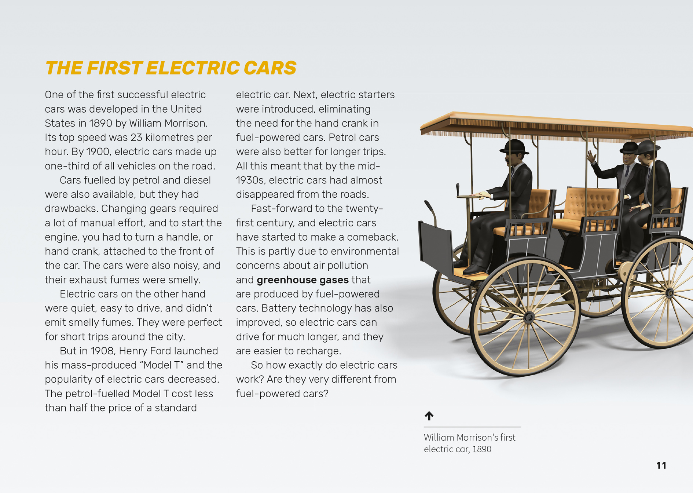

Societal and environmental issues can influence the production of technological outcomes.
Science and technology together produce a range of possible solutions for a specific need or opportunity.

Learning activities – Link to technology
The following activities are a guide for supporting students to explore and develop understandings about technological development and outcomes.

Activity 1 – Creating our own energy conversion machines
Remind the students of the diagrams they created to show how cars transform potential (stored) energy into kinetic (movement) energy. Reinforce that all vehicles are “energy conversion machines”. Discuss the different components of cars that are involved in this conversion.
- What were the similarities and differences in the two types of cars?
Challenge the students to create their own vehicles. Encourage them to take on the role of engineers who develop a brief, test their inventions, and use the information they gather to refine their prototype and make it better. Explain that their solutions will be judged on a range of indicators, including speed, distance travelled, and running time. Different designs may prioritise different goals. Note that the resource links include instructions for making vehicles.
When the students have designed their prototypes, set up a competition. This will also be a focus for the students to collect data to compare the merits of each design. Questions they could ask include:
- What sorts of measurements will we need to make?
- How should we record the data?
- What is a good way of organising the data so we can make comparisons?
- What can we conclude about effective ways to transform potential energy into kinetic energy?

Activity 2 – Who killed the electric car?
The article gives economic and technological reasons for the decline of the electric car and its eventual resurgence, but are they the only reasons? A 2006 documentary called Who Killed the Electric Car? describes how electric cars made a resurgence in the United States in the 1990s and were then deliberately knocked back ten years later. The filmmakers argue that this was the consequence of deliberate resistance to this technology from car companies and politicians.
While the film may be too long for classroom viewing, the students could view and analyse clips. The Take Action page of the film’s website includes a teacher’s guide that provides an index of specific clips and suggestions about how to approach discussion.
Since the film was made, there appears to have been a change in attitude by car companies and politicians, and greater support and investment is now going into developing electric vehicles. The students could explore whether this is so and why that might be.

Activity 3 – What does the future hold?
Reread the final section of the article and discuss the students’ responses to the question “What does the future hold?” Use this as the springboard for group inquiries into possible car technology in the future (for example, solar-powered cars, hydrogen cars, or self-drive cars). Have the students present the results of their inquiries to each other, supporting a visual presentation with a verbal presentation. Have them take notes of each other’s presentations. Afterwards, discuss the developments the students think are most likely in the next five years. Press them to justify their opinions with evidence.

Learning activities – Link to technology

RESOURCE LINKS

Connected  “The Steam-powered Car: Time for a Comeback?” Connected 2, 1999, pp. 11–15  Building Science Concepts  Book 42, Marbles: Exploring Motion and Forces  Book 59, Bikes: Levers, Friction, and Motion  Toy vehicles  Balloon-powered car: www.stevespanglerscience.com/lab/experiments/balloon-powered-race-car/  Balloon-powered car challenge: www.sciencebuddies.org/science-fair-projects/project_ideas/Phys_p099.shtml#procedure  Electric car: www.miniscience.com/kits/CAR_ELEC/  Rubber-band car: www.hometrainingtools.com/a/rubberband-car-project  Societal issues that may have impacted upon the development of the electric car  Website: www.whokilledtheelectriccar.com/  Movie: http://streamalone.com/play.php?movie=tt0489037  EV1 Behind the scene – Our sole mission: more about the destruction of the EV1: www.ev1.org/  Electrifying cars: How three industries will evolve www.mckinsey.com/industries/automotive-and-assembly/our-insights/electrifying-cars-how-three-industries-will-evolve | Electric cars  General information on electric cars: www.energywise.govt.nz/on-the-road/electric-vehicles/  www3.jjc.edu/ftp/wdc11/drucker/  www.explainthatstuff.com/electriccars.html  www.kids.esdb.bg/smart_inventions.html  http://autocaat.org/Technologies/Electric_Machines_and_Power_Electronics/  History of electric cars:  http://energy.gov/articles/history-electric-car  Internal combustion engine: http://energy.gov/eere/energybasics/articles/internal-combustion-engine-basics  Diagram of electric car: http://ww1.prweb.com/prfiles/2008/05/23/463434/crosssection.jpg  Cars of the future  Solar-powered cars: www.technologystudent.com/energy1/solcar1.htm  Google self-driving car: www.google.com/selfdrivingcar/  The cars we’ll be driving in the world of 2050: www.bbc.com/future/story/20131108-what-will-we-be-driving-in-2050

