Coraline
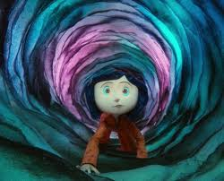
Study Guide

Directed by: Henry Selick

Synopsis
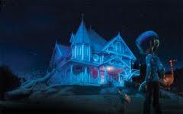
Henry Selick [The Nightmare Before Christmas, James And The Giant Peach] presents another stop-motion animation based on Neil Gaiman’s book of the same name. Coraline tells the story of a young girl who unlocks a mysterious door in her new home and begins a strange and scary adventure in a parallel reality.

Before Seeing the Film

Making predictions

- What type of film do you think Coraline will be from reading the synopsis? __________________________________________________
__________________________________________________
__________________________________________________
__________________________________________________
__________________________________________________

- Will it be a comedy? An action adventure movie? A scary movie? Write a few sentences explaining your choice of genre. Select words from the synopsis to back up your opinion. _______________________
___________________________________________________
___________________________________________________
___________________________________________________
___________________________________________________

Choosing and Using Stop-Motion

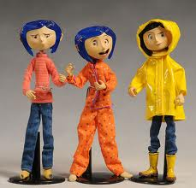

Coraline is an animated film produced using stop-motion animation.
This is a painstakingly slow process where models are used to create the action. A picture of the model is taken, then it is moved slightly, then another picture is taken and so on: the process is repeated thousands of times to make the film. Eventually, the pictures are put together and played quickly one after the other, so it looks as if the model is moving. This method of filming takes many hours to produce just a few seconds onscreen. Coraline was also filmed in stereoscopic 3D (although you may have seen the regular 2D version).

- What other stop-motion animation films do you know of? What makes them different to other children’s films? _____________________________
________________________________________________________
________________________________________________________
________________________________________________________
________________________________________________________

- This film is produced by Henry Selick, who also worked on the films ‘The Corpse Bride’ and ‘The Nightmare Before Christmas’. From what you know about these films (just go by the titles if you haven’t seen them), what sort of film do you think Coraline might be? ___________________________________________________
___________________________________________________
___________________________________________________
___________________________________________________

- 3D films have been around for some time and right now they are becoming increasingly popular. What other 3D films do you know about? Do they have anything in common with Coraline, or with each other? ___________________________________________________
___________________________________________________
___________________________________________________
___________________________________________________
___________________________________________________
___________________________________________________
___________________________________________________

After Watching the Film

Opening Sequence

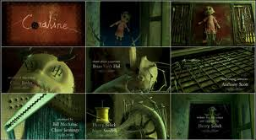

The very first scene of the film was also one of the first pieces of the film to be finished. This was used as a ‘teaser trailer’: it appeared on websites and in cinemas to give fans a taste of the film before it was released. By doing this, the filmmakers hoped to build excitement about Coraline and encourage people to see it when it arrived at the cinema.

- What do you remember about the very first scene? (Hint: before we see Coraline, we see a miniature version of her being made...) __________
_________________________________________________________
_________________________________________________________
_________________________________________________________

- Thinking about how the story develops what do you think this first scene ‘means’? What ideas does it give you to explain what happens in the rest of the film? __________________________________________________
__________________________________________________________
__________________________________________________________
__________________________________________________________

A Fairy Tale Setting

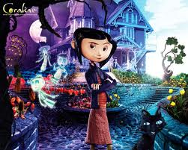

Coraline is similar in some ways to a fairy tale, though it is a modern story.

- List three or four fairy tales that you know of. What settings are there in these different stories? Do some settings seem to come up again and again in different stories?
  - _________________________________________________
  - _________________________________________________
  - _________________________________________________
  - _________________________________________________

- Now think about the setting of Coraline in the first few scenes. Do the locations you see match up with any of the fairy tale settings you know? ___________________________________________________
___________________________________________________
___________________________________________________

- Does the setting for Coraline have anything in common with other kinds of story that you know of? _________________________________
____________________________________________________
____________________________________________________
____________________________________________________
Family Life

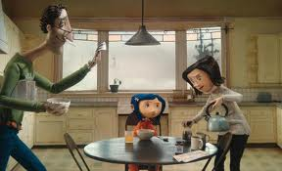

When we first meet Coraline, she has just moved to a new house with her parents. It’s the start of the school holidays and, with both of her parents working at home, she quickly gets bored.

Creative Writing Task:

1. Imagine you are Coraline, before she finds the secret door. Write a postcard to your friends in your old town, describing the new house and your new life here. Who have you met? What have you seen? What plans have you made? What are your hopes for the future? Things you could mention:
– the house
– the woods
– Wybie
– the cat
– Miss Spink and Miss Forcible, and their dogs
– Mr Bobinksy

2. Draw an image for the front of the postcard based on one or more of these. Think about a border and design a stamp to go on it too.

(Ask your teacher for some materials to use- coloured/white paper or card, scissors, glue, felts, colouring pencils etc…)
Characters and Roles: Making Sense of the Story

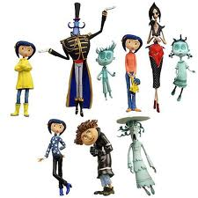

It has been said that many stories fall into similar patterns, with the same kinds of characters appearing again and again. In fairy tales this is particularly true. Think about the characters of the evil stepmother, the princess or the prince: these characters pop up in slightly different forms in many different tales. The table on the following page shows one way of thinking about characters in a story, by looking at the ‘role’ they play.

1. First of all, fill in the gaps with examples from fairy tales.
2. Now think about the characters in Coraline, listed below: where do they fit in the table? Some of them may fit into more than one box.
3. Are there any characters that don’t seem to fit any of the boxes?
Characters in Coraline:
– Coraline
– Real mum
– Real dad
– Other mother
– Other father
– Wybie
– The cat
– Mr Bobinsky
– Miss Spink and Miss Forcible
– The ghosts

Name  of role | Description  of role | Examples from  fairy tales | Characters  from Coraline
Hero | This is the main character in the story that the audience supports. Generally they act for good, though they may have challenges to face as the story develops.
Dispatcher | This person sets the hero a challenge or sends them on a quest. There may be more than one dispatcher in a story.
Helper | This character might guide the hero throughout the story, or they might appear just at the moment they are most needed to save the hero from trouble.
Donor | The donor gives something to the hero to help them along their way (hint: several characters help Coraline as the story develops…)
Princess | In traditional tales the princess is the character who needs to be rescued by the hero (hint: the role of the ‘princess’ doesn’t have to be played by a girl…)
Villain | This character works against the hero, trying to stop them from completing their quest. Generally their intentions are bad; although they may try to trick other characters into thinking they are good.
Who Are You???

Now let us learn a bit more about the characters of Coraline- their appearance, character traits, goals/motivations and how other characters and the setting affect them. Use the chart(s) to write about Coraline. Then choose one other character from the film to fill in for the other chart(s).

Character: Coraline
Appearance | Age:
Appearance | M/F:
Appearance | Clothing:
Appearance | One Word Description:

Character Trait | We see this when... | Direct Quote

Character Objectives | What is/are this character’s main wants and needs (motivation)? | What does this character do (actions) to get what he/she wants? | What or who stands in the way of this character getting what he/she wants? How?

Setting/Scene | Affects the character... | Direct Quote
Character:

Appearance | Age:
Appearance | M/F:
Appearance | Clothing:
Appearance | One Word Description:

Character Trait | We see this when... | Direct Quote

Character Objectives | What is/are this character’s main wants and needs (motivation)? | What does this character do (actions) to get what he/she wants? | What or who stands in the way of this character getting what he/she wants? How?

Setting/Scene | Affects the character... | Direct Quote

Behind the Door

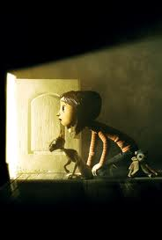

When Coraline first crawls through the secret passage behind the cupboard door, she emerges into a parallel world which at first glance is similar to her own world, but with some key differences. On the other side of the door Coraline’s room is full of fascinating toys; her parents have all the time in the world to play with her; even the food tastes better. But all is not as it first seems.

Activity:

One of the main differences between the ways the two worlds look in the film is the colour palette that is used. Create a colour palette for the film before Coraline climbs through the passage, and one for afterwards.
– What types of colours are used in each world?
– How do the different colour palettes change the feel of the story?
– What if the colour palettes were reversed?
(Create your colour palettes on a separate piece of white paper using coloured pencils, crayons or felts. Write your answers to the above questions underneath each colour palette- see your teacher for materials)

Real and Other
Coraline’s real world and the Other World are two very different places. We know this, but we are also shown this through the different effects used in each place.
Discuss the differences and explain the effect achieved in each case.
 | Action/Relationships/  Characters | Lighting / Colour / Special Effects | Soundtrack  (music, dialogue, background sounds)
The Real World
The Other World
Another Mother?

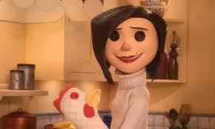

Coraline’s Other Mother seems perfect at first glance – but after a while, it isn’t only her button eyes that are frightening.

- When do you first get the impression that life on the other side of the little door isn’t as good as it first seems? What details give you this impression?______________________________________________________________________________________________________________________________________________________________________________________________________________________________________
- As the story progresses, how do the actions – and appearance – of the Other Mother and the Other Father change? ________________________________________________________________________________________________________________________________________________________________________________________________________________________________________________
- Why do you think the Other Mother wants Coraline to stay in her world with her? _______________________________________________________
____________________________________________________________________________________________________________________________________________________________________________________
Activity:
On the next page reinvent another you. Draw a self portrait but change things about your appearance so you look other worldly. Your other self may look gruesome, scary, funny, stereotypical fairytale or.....? Be creative with costume, hair, colour and facial expressions.

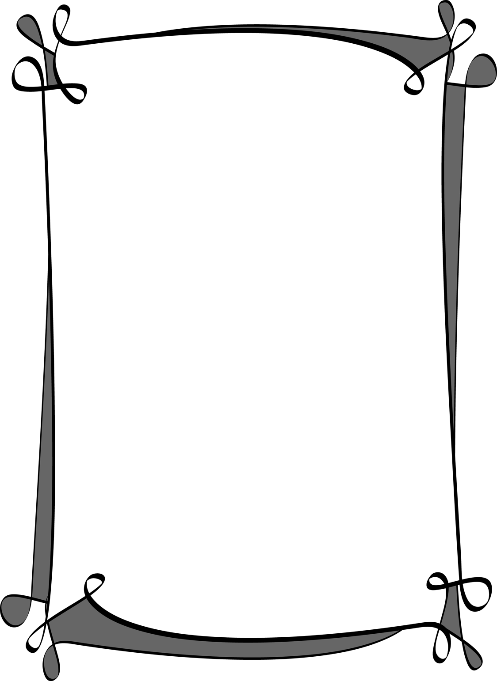
Film Elements
Story Elements- Theme(s), character(s), setting, storyline/plot, time, narrative point of view (POV), conflict, and tension.
Production Elements- Camera angles & shots, lighting, soundscape, visual composition (mise-en-scene), costume, set design, acting, and editing.

Tension and Suspense:

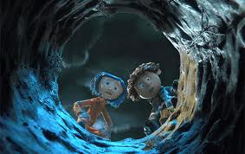

1. In a small (2-3) group, write down all the key moments you can remember from watching Coraline.

2. Once you have written down as much as you can remember, work out which order these moments came in the film – you can do this by giving each moment a number.

3. When you have all this information together, turn it into a tension graph – a line that goes up at the moments of highest tension and down again during calm or happy moments. Write the key moments in the space along the bottom, like in the graph example on the next page.

Example:
4. What shape does your graph take? How does it compare to other groups’ graphs?
Draw your graph below:

Basic Camera Shots and Angles:
Using the list of angles & shots and the examples from Coraline below decide on which type of camera shot and/or camera angle is used for each example and why it is used (you can also refer to sheets provided by your teacher).
Activity:
Angles:
- Eye-level
- High Angle
- Low Angle
- Birds Eye

Shots:
- Close-up
- Extreme Close-up
- Mid Shot
- Long Shot
- Extreme Long Shot
- Point of View / Subjective

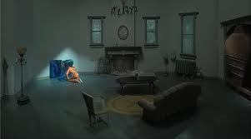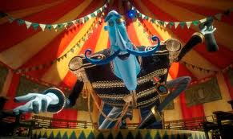
_________________________ _________________________
_________________________ _________________________
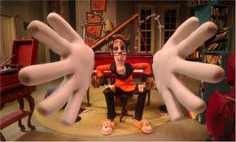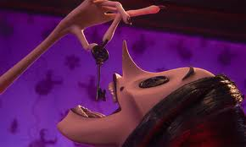
________________________ ________________________
________________________ ________________________

Camera Movement:
- Panning- a movement which scans a scene horizontally.
- Tilting - a movement which scans a scene vertically
- Zooming- changes the magnification of an image

Lighting:
- Soft Lighting- refers to light that tends to "wrap" around objects, casting shadows with soft edges. Sometimes referred to as fill lighting. When the sun is behind clouds in the sky, this creates soft lighting.

- Hard Lighting- often creates harsh, sharp-edged shadows. Direct sun overhead on a bright sunny day is an example of hard lighting.

- Key lighting- lighting which selectively illuminates from the front various prominent features of the image, such as faces or hands, and provides the reflected gleam in an actor’s eye.

- High-key (realistic) lighting - lighting style in which all parts of the set and the screen are relatively evenly lit, suggesting a familiar world containing few surprises or mysteries.

- Low-key (expressionistic) lighting - lighting with strongly contrasted areas of light and shadow, often with one feature of the image lit from one side or below and the rest dark, creating a sense of lurking mystery (called low-key because the key light is turned ‘low’ or ‘off’).

Lighting Activity:
Describe the lighting in each of the shots below. What is the effect of this lighting for the viewer? Why do you think the director chose to light this scene this way?

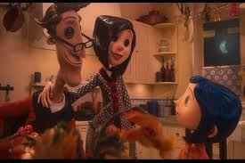
__________________________ ____________________________
__________________________ ____________________________
__________________________ ____________________________
__________________________ ____________________________

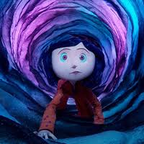
______________________ __________________________
______________________ ___________________________
______________________ ___________________________
______________________ ___________________________

Music and Sound

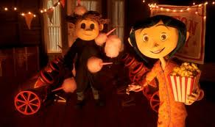

Filmmakers include sound and music because:
- They give the audience clues to the emotion(s)...
  - Tells us how characters personally feel.
  - Tells us about how they feel towards other characters.
  - Lets us know how we should feel.
- It creates the atmosphere/mood of the scene:
  - For instance, music can be used to tell the audience when something is supposed to be frightening and dark

There are two types of cinematic techniques for sound used in film:

Diagetic Sound (actual sound):
- Sound or music recorded in the movie’s world. Example: a door closing, gun being fired, police siren.
Non-Diagetic Sound (commentary sound):
- Sound or music that is added to the film during the editing process. Most often, non-diagetic sound is music.

These cinematic techniques, along with dialogue, musical score, sound effects and voice over make up the soundscape of the film. A soundscape is an atmosphere or environment created by or with sound i.e. the raucous soundscape of a city street; a play with a haunting soundscape.

Activity:

Choose a moment from the film where the music, or a particular song, was important.

What was happening in that scene? ________________________________________________________________________________________________________________________________________________________________________________________________________________________________________________________________

How would you describe the mood of the music? ________________________________________________________________________________________________________________________________________________________________________________________________________________________________________________________________

How important was the music in creating the atmosphere in that scene? ________________________________________________________________________________________________________________________________________________________________________________________________________________________________________________________________

Compose your own ‘soundscape’ to create a tense or ghostly atmosphere. Think about what sounds and instruments you could use to make listeners feel tense: will there be any sudden moments that make you jump? Will some sounds be louder and some quieter? How could you use voices – for example, chanting or whispering – to create effects?

________________________________________________________________________________________________________________________________________________________________________________________________________________________________________________________________________________________________________________________________________________________________________________________________________________________________________________________________________________________________________________________________________________________________________________________________________________________________________________________________________________________________________________________________________________________________________________________________________________________________________________________________________________________________________________________________________________________________________________________________

Fantasy and Imagination

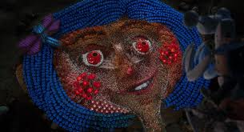

Life on the other side of the secret door is full of magic and wonder, from Mr Bobinsky’s mouse circus, to Miss Spink and Miss Forcible’s incredible show. At one point in the film, Coraline walks into a magical garden that literally comes to life.

Activity:

Imagine if you walked into your school grounds and the plants, creatures and insects came to life- or even the buildings.

Storyboard a scene of this using the sheet on the next page. Use vivid colours to make it more magical. Each frame needs to have a specific picture. Remember to include types of camera shots and angles, characters within the shot(s), and any dialogue or SFX you may want.

(Use the film elements and techniques guide provided by your teacher to help you).

Activity: Your Own Stop-Motion Animation:

You will now choose a shot/frame/scene from the storyboard you have written and illustrated, and using plasticine you will create your own 3D scene!

You will then have the opportunity to film/capture your shot using a digital camera to create your own motion animation.

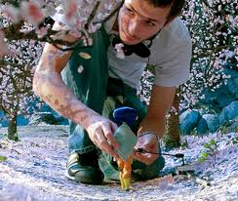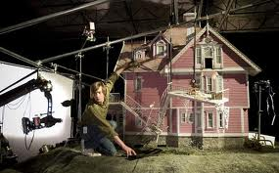

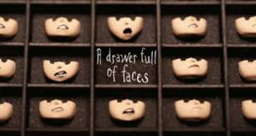

Assessment Essay

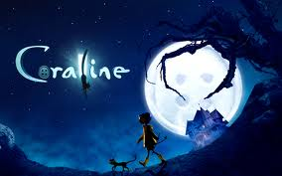

In groups of 2-3 you will read a film review of the movie Coraline. You will then write down in your workbooks a list of the kinds of things that reviewers mention when reviewing a film. You will then draft, edit and publish on A4 refill paper your own Coraline film review following the layout below. This will be your summative assessment for this film study, therefore you will need to use all the information and learning you have acquired throughout the unit to inform your writing. Your teacher will advise you of due date.

Coraline Film Review
Introduction
- Introduce your review by giving the name of the film, director and date released.
- Give the main characters and who they are played by.
- Discuss the type of special effects used in the film-making process.

Plot
- Summarise briefly the key incidents from the film.
- This should be about 5-10 lines and no more.
- Tell us the message/theme running through the film.

Coraline
- Describe Coraline as the main character
- Use your knowledge of her behaviour to inform your paragraph
- Mention how she is represented through filming techniques (colour, lighting, music, mise-en-scene)

Characters
- Choose 1 other of your favourite characters from the film and describe what it is about them that make them interesting.
- Mention soundtrack, lighting, behaviour, colour, voice etc...

Analysis of Key Scene
- Discuss one particular scene that you found taught you something about elements and techniques of film (you can choose one of the close view ones used in class, or your own choice).
- Describe how the different filming techniques (camera, soundtrack, lighting, colour, mise-en-scene) influence our viewing of this scene. Give examples.

Conclusion
- Summarise the main points of your essay (say what it is you looked at).
- What is the message of Coraline? Or what did you learn from watching it? Give your personal opinion of the film and why you think that.

Further activities

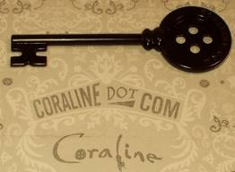

- When Coraline is sent exploring by her parents, she discovers that her neighbours are a little eccentric to say the least. Mr Bobinsky, the man who lives above Coraline, has smelly cheeses delivered to him in the post. The two actresses who live below her have a room full of their ‘dear departed’ dogs – stuffed. From what you can remember about these characters, their houses, their actions and their words, write a ‘back story’ for each character. Where does he or she come from? How have they ended up living next door to Coraline and her family? Why are they the way they are?

- Imagine you are one of the ghosts: a previous victim of the Other Mother who wasn’t as lucky as Coraline. Tell your story: how did you get there? You should write in the first person, as though you are the ghost.

- Design your own ‘other’ world. What magical or wondrous things are there? What frightening and threatening things might be revealed? Make drawings of the key settings and main characters and write descriptions for each.

The official website for the film has lots to explore and to entertain. You can visit it at www.coraline.com. Or visit www.neilgaiman.com to learn about the author of the story.

(Resources collated and re-interpreted from www.filmeducation.org, Portree High School, and the Internet).

