Example from Practice
School Descriptor | Urban, Single-sex (Male)  Size: 637  Demographics: Decile 6. New Zealand European/Pakeha 36%, Māori 15%, Samoan 14%, Indian 9%,Chinese 5%, Other Pasifika 2% and Other Ethnic Groups 11%.
Class Descriptor | Subjects: Social Studies and Science  Year Level: 10
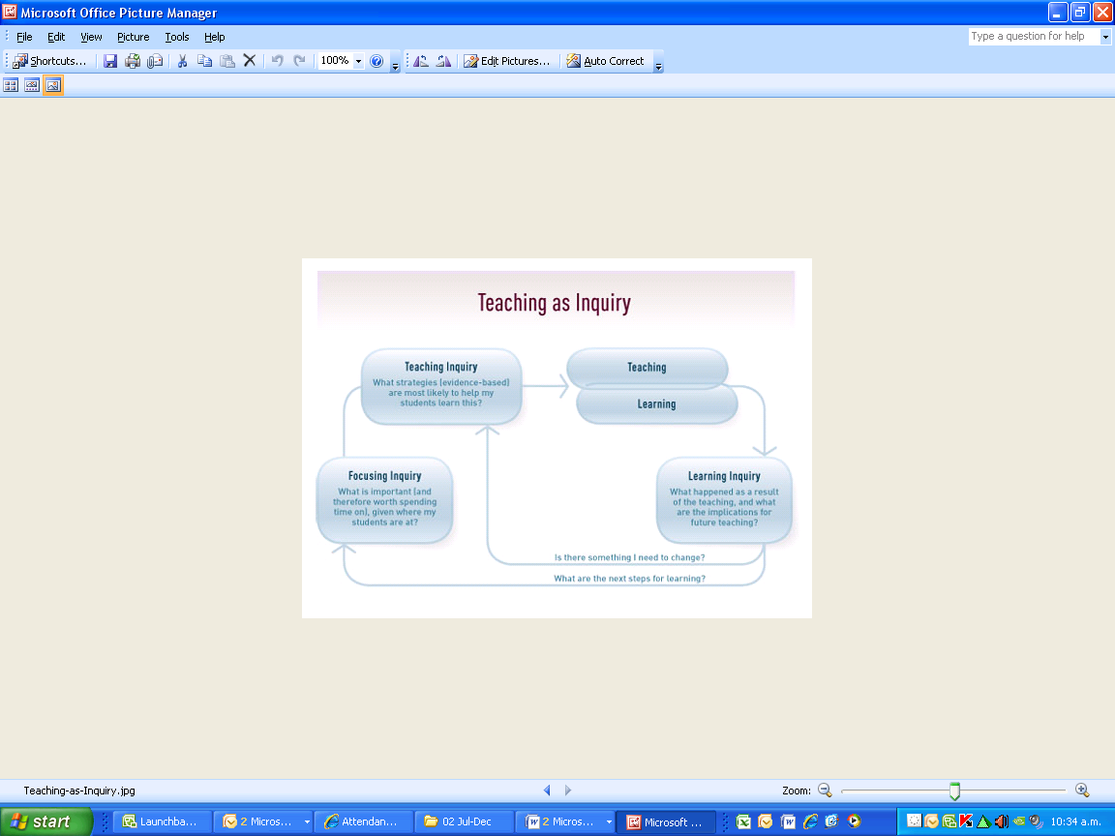 | Overview/context/focus group of learners  The Social Studies and Science teachers of this class found that students were struggling to read and select relevant information from texts and to process the information in order to present findings for research projects. Students presented work that had largely been ‘cut and pasted’ from web sites without acknowledging sources of information. In each learning area, students engage with reading and understanding relevant texts as part of their developing repertoire of literacy skills and knowledge (NZC p.16).  Nature of the inquiry, based on evidence  The teachers and the literacy facilitator looked at students’ class work that had been completed as preparation for two research projects. They found that when students had been asked to ‘make notes’ they did not know what to leave in or take out so they copied everything or did not do the work. Previously completed research projects showed that, although the presentation of the work was good, the content of the written text was clearly not the students’ independent work.
Planning undertaken by teachers

The teachers decided that the students in this class needed to learn how to make notes from texts that would be useful in assisting them to present information. They discussed the concept of independent literacy strategies with the class and how these could help students with processing text. A note-making strategy adapted from RAP, (Shumaker, Denton & Deshler, 1984) called “Peer Assisted RAP” was taught to the class and used regularly in Science and Social Studies classes.

Peer Assisted RAP involves students learning a series of steps which they repeat with each paragraph of a text until they have made notes on the whole text. RAP is an acronym for ‘Read’, Analyse (Ask questions) Paraphrase (Put in your own words). The questions are: “What is the main idea in this paragraph? and “What are two details?”

- Students worked in pairs and each student read the paragraph aloud
- They asked each other “What is the main idea?” and came to some agreement.
- They asked each other “What are two interesting, relevant details?”
- Main ideas and details were written in students’ own words.

The RAP strategy was modelled with the class as a whole group using the same text to teach them the process. The Science and the Social Studies teachers both used the strategy at least once a week for about six weeks. Once the students were confident they understood the process they worked in pairs on different texts. After some time many students were able to use the RAP strategy independently and could dispense with the repeated reading of the text in pairs.
Once the students realised they would be using the strategy frequently and that the teachers were looking at their work there was some ‘buy in’; they realised that note-making was a priority for their class. They had most difficulty with the questions; working out what was the main idea and what two details might be was challenging for these students. There was a lot of oral work and teacher modelling at the beginning. Students had to hand in their RAPs once a fortnight and the teachers tracked their progress on a grid.

The thinking behind the strategy is what makes RAP an effective note-making tool. Students are supported to think about one paragraph at a time which makes the analysis more manageable. Discussion around the most important piece of information in each paragraph assists students to negotiate an understanding of the ideas in the text. Students are actively engaged with text rather than passively copying down chunks of text. Working collaboratively to develop understanding of the main ideas makes the task less daunting for readers who find academic texts very difficult.

Another focus for the teachers was to teach students how to acknowledge sources of information.
They taught students a very simple referencing format using the Author’s Last name, First name and initial or Middle name. Italicize or underline title. Place: Publisher, date of publication.

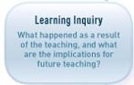 | One of the positive outcomes was that students reported that they felt that this was a strategy that could help overcome their fear of challenging text. They came to know the process very thoroughly and they supported each other when they got stuck on identifying main ideas or details. It was evident that they improved their skills at identifying main ideas and details and got better at putting ideas into their own words. They became more independent at working out what words meant by using the context and they used the dictionary more than they had before they learned this strategy.  One of the teachers said: “I think they started reading more as they had a way to get into the text if straightaway they didn’t understand it. They asked themselves questions: What are the words I don’t know? How I can figure them out? and then, What is important? (RAP) Gave them a platform or foundation. Confidence.”

