Example from Practice
School Descriptor | Rural/Urban – Urban provincial city  Size (Large/medium/small) – small (230 students)  Demographics – Decile 3: 33% Maori, 8% Pasifika, 31% NZ/European, 27% Other
Class Descriptor | Subject – Mathematics  Year level –11 - Mathematics curriculum level 6 and assessment outcomes for NCEA Level 1
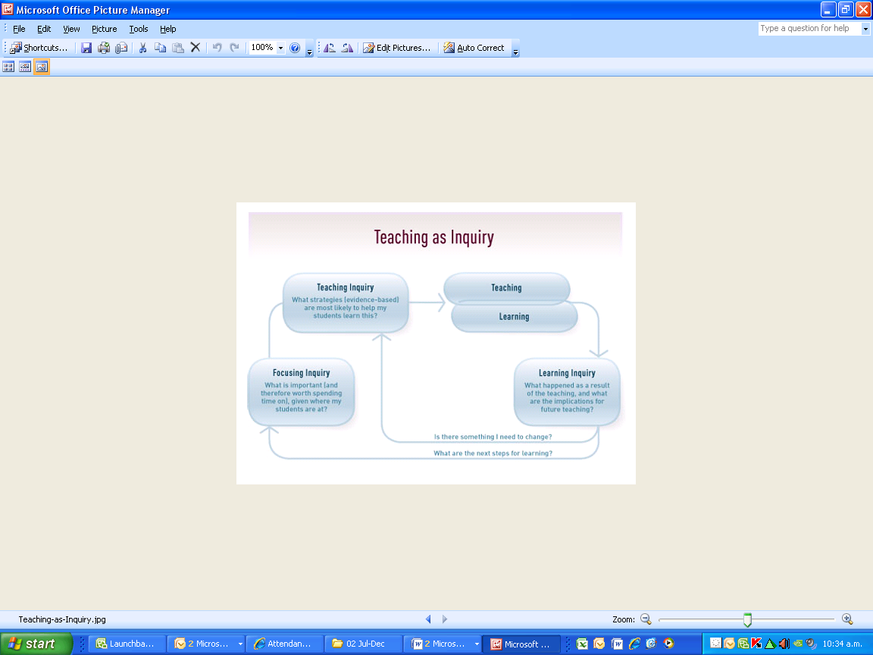 | Overview /context / focus group of learners  The group of learners have high mathematical ability (average of Stage 7/8 of the Secondary Numeracy Project and strong literacy levels (average e-asTTle curriculum sub-level 4P, min 3P to max level 6B as Yr 10’s.) They possess the academic potential to succeed in NCEA level 1 with the appropriate scaffolded teaching approaches. The challenge for the year (2011) was to best prepare students for the mathematical literacy demands of the Mathematics Curriculum, Level 6. The curriculum expects teaching, learning and assessment activities to provide richer, more open tasks, rather than the traditional textbook style exercises that progressively get more difficult. The students have to learn how to reason out their thinking, process the context of a problem, communicate with appropriate mathematical statements and relate their solutions to the context of the problem.  Nature of the inquiry, based on evidence  The inquiry centres on this key question:  How can I support students to communicate, in writing, their mathematical thinking as they solve a problem which yields to many different approaches, and relate their solution and thinking to the context of the problem, in order to achieve at Merit and Excellence?  The inquiry emphasises that students need to select and use relevant methods to solve the problem, because the set tasks do not necessarily make one method obvious. Students therefore need to be exposed to rich open tasks in order to practice this skill and to succeed in this type of assessment, an approach that is embedded in the curriculum and has been highlighted by the realignment process. The sample tasks for the realigned standards require students to be more discerning about how they will select and use mathematical methods and approaches.  A second inquiry question emerged out of the sample realignment tasks:  : How do I support students to move into problem solving that goes beyond the mechanical “answer the question” methodology, which has characterised traditional mathematics teaching and assessment for many decades?  Literacy levels play a pivotal part in the deeper cognitive processes identified here. Firstly, students must make connections between different aspects of text in mathematics, to draw out the key information, to process this into a mathematical expression/operation, and to solve the problem in context. Secondly, it is crucial that students be able to communicate in writing, the required problem-solving steps, and to show how they reason out a method and relate their solutions to the context of the problem.  Such literacy skills are pivotal because a student may know how to calculate a fraction or a percentage, or even more complex mathematical calculations, but if they cannot infer from a task that such calculations would be appropriate then they are unable to respond to the demands of the task. In effect, they stumble at the first hurdle.The important questions students must address are: How does the task require me to respond, and secondly, to what extent does my critical comprehension of the task impact on my level of achievement?  The mathematics curriculum places thinking at the centre of teaching and learning. The tasks for the realigned standards provide opportunities for students to demonstrate high levels of thinking because they require students to: make connections within text, infer for deeper meaning, reason deductively, choose and apply relevant information, and accurately write mathematical reasoning.  These are important academic literacy skills that mathematics teachers must strategically teach their students.
Planning undertaken by teacher(s)
The teacher analysed the sample tasks for the realigned standards and the exemplars to fully understand the holistic cognitive demands within the progressions of Achieved through to Excellence.
She ascertained the extent to which students’ prior knowledge and experience would prepare them for their mathematics work.
She then analysed what literacy skills and strategies students would need to learn in order to successfully meet the standards set out at Achieved through to Excellence. The analysis identified making connections within a text, transferring knowledge from one context to another, and reasoning and discussing in order to communicate their thinking around a problem. Then she sought relevant instructional literacy approaches that helped scaffold the application of these required skills.
Informed by research /evidence
This work is informed by research and evidence emerging from SOLO and Bloom’s taxonomy literature that mapped the attributes of increasingly challenging cognitive development within a mathematics learning context. This was a taxonomic progression from Pre-structural to Uni-structural, Multi-structural, Relational and finally Extended Abstract understandings of mathematical concepts and methods.
In particular, the teacher identified that within the cognitive taxonomy process a multi-structural understanding of problem solving constitutes the threshold students must cross to attain an Achieved or better.
Approaches to Teaching and Learning undertaken
The teacher adopted approaches that required considerable oral and written language development. Adopting these approaches enabled her to accelerate the learning of students who might otherwise have struggled to comprehend the nature of the problem confronting them.
The mathematics text was used as a source of information, and literacy strategies were employed around text structure, surface and deep features of the text to extract and infer what was relevant to the problem. This involved definitions, terminology, developing worked examples and writing to describe important features of the student’s reasoning process. The writing was evidence that the students were reaching key points in the work. These approaches were undertaken because students need to be able to draw out the mathematical concept from the word scenario/context.
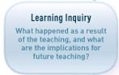 | What happened and implications for future  The students started to make the connections between their prior knowledge of mathematical skills and the context of the questions that are posed in rich tasks and in the assessment activities written for the realigned level 1 internal assessments,  Student efficacy increased. Students are able to articulate verbally and in writing what is going on in their heads as they attempt to solve the problems. They now understand mathematics as a process rather than just getting an answer as an outcome.  This work has confirmed the importance of explicitly teaching problem solving strategies as tools that students can use to access rich tasks and unfamiliar contexts  The next steps are to continue to further adapt the teaching and learning approach by teaching the skills of the mathematics learning area in a holistic way, through the regular use of rich tasks and contexts that the students may be familiar with, and then lead them into more challenging tasks in increasingly unfamiliar contexts.

