Example from Practice
School Descriptor | Urban  Size: Large 2289  Demographics: Decile 7. NZ European/ Pakeha 45%, Maori 14%, Pacific 19%, Asian 16%, Other European 3%, Other 3%
Class Descriptor | Subject : Maths  Year level: 9
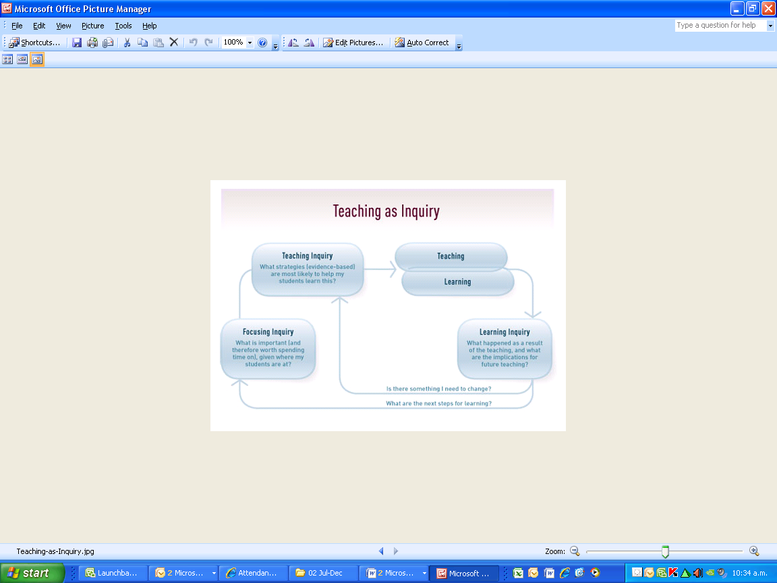 | Overview /context / focus group of learners. The teacher noticed that many students in this class were having difficulty understanding and interpreting information accurately when presented with maths word problems.  Nature of the inquiry, based on evidence  Analysis of the e-asTTle reading data for this class showed that most students were reading at level 3 of the curriculum, one student was reading at level 4 and three students were reading at level 2. From the e-asTTle group learning pathways report, understanding and identifying information accurately was identified as the highest learning need for this class. The teacher noticed that most students were able to use the correct algebraic skill to solve simple mathematical equations. However when the mathematical problem was presented as a word problem, most students did not know where to begin to solve the problem.  The teacher identified that the problem was that students were not able to extract the maths from the context. The teacher hypothesised that this issue might be due to factors such as:  - Students did not have the prior knowledge of the context  - Students had a limited vocabulary  - Students were not able to identify the mathematical problem from the contextual words  In order to test these hypotheses, the teacher interviewed one group of students informally as part of a lesson and found there was evidence for each. For example, students said they much preferred doing the mathematical equation than when it was presented in words as “ the words just confuse me, so I don’t know where to start ”, and “I get stuck on some words I haven’t seen before”. Many students could not articulate any strategies they used to help them identify the key words apart from underlining the numbers which only a few students articulated.
Planning undertaken by teacher(s)
Over the course of the alegbra unit, the maths teacher worked to improve students’ ability to read mathematical word problems. The areas identified for improvement included:
- Increasing the numbers of opportunities students had for solving word problems collaboratively in groups
- Supporting groups to be very structured with explicit reading strategies being role played (e.g. R.A.P. see below) and group roles to be adopted (e.g.co-ordinator, energizer, elaborator)
- Modelling explicit reading strategies that were to be used in the group work, RAP: 1. Read the problem carefully. 2. Ask three questions –What do we have to find out? What do we know? How will we do it? 3. Paraphrase-put it in your own words and solve it.
- Modelling explicit reading strategies such as ‘trash or treasure’ to help students identify the key words from the context.
- Co-constructing with students an understanding of the text features and purpose of the word problems
- Supporting students to translate the word problems into different textual forms ie diagrams, tables, mathematical sentences
- Modelling ‘think alouds’ to simplify the problem
- Gathering student voice to monitor the effectiveness of the reading strategies and feeding back to the students about the collective learning in regards to the reading strategies
The teacher continued to monitor students’ ability to solve word problems throughout the unit. At the end of the unit the teacher set an asessment task that contained a variety of word problems and he re-interviewed the same group of students. He also asked all students to list the strategies they could use to solve word problems.
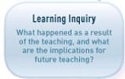 | In the end of unit assessment, all but three students had attempted all of the word problems with varied mathematical success. What the teacher did notice was students were much more resilient in reading the word problems and able to start solving the mathematical problems with more confidence. On their assessment papers, nearly all students were underlining the correct key words that were needed to solve the word problems and using this information to write mathematical sentences and/ or draw visual representations of the problem. When the teacher collated the student feedback at the end of the unit, he noticed that most students were able to list a range of reading strategies that helped them solve word problems. The most common strategy articulated was the ‘trash or treasure’ strategy and drawing a diagram. The students that were re-interviewed were able to articulate a range of reading strategies, they also commented that “I like working in groups as I can get help from others” and “Before I didn’t know how to paraphrase but through working on this with my group, I now use some of the key words from the word problem but use other words to make the problem make sense”.  Another issue that the teacher identified was that students were not checking their answers made sense or writing sentences using the correct terminology. This became the goal for his next unit.

