Our Cultural Village - Afghanistan
Content categories | Links to and description of content
Comments and suggestions
Online dictionaries |   Pashto Dictionary definition of the Pashto language.    Freeland.net online dictionary Introduction to Afghanistan.
Maps/Flag | Images of flags in Afghanistan from 1901  Afghanistan map National Geographic  Afghanistan map Lonely Planet  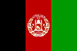  Image of the flag
Images of Afghanistan  Landscape and people | Slides: Afghanistan images  Images of Afghanistan  Images: The daily life of Afghanis in the late 1960s  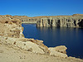  Image: Lake Band-e-amir and limestone canyons
Food | 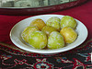  Image: Fruit |  | 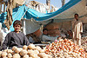  Image: Salesman |  |  | 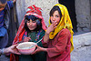  Image: Food aid | 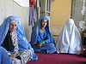  Image: Women at a Poultry Association Meeting
Culture | Video: An exhibition of contemporary art from Afghanistan, Pakistan and Iran, held in Kabul.  Afghan Star - a documentary about Central Asia's version of American Idol and the perils involved for women contestants.  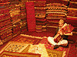  Image: Carpet seller in Kabul
Faith | 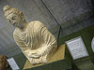  Image: Buddhist figure in the Kabul Museum | 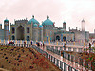  Image: Blue Mosque
Politics | Slides: Long term solutions for Afghanistan  Slides: Women's shelters in Afghanistan
 | 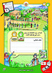  Image: Election poster | 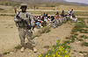  Image: U.S. soldiers in Afghanistan
Information  History | 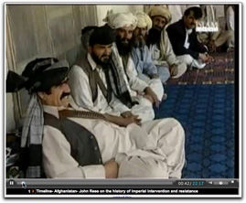  Video: History of Afghanistan
Language | Kwintessential Cultural Awareness guide - a guide to language, culture, customs and etiquette  The Dari Alphabet  The Pashto Alphabet
International Aid | The Department for International Development in Afghanistan - an overview of the country with maps, links to multimedia, and insights into some of the initiatives uderway in the country.  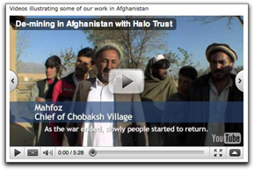  Film showing how the Halo Trust is making the countryside in Afghanistan safe for people to live in and farm again, by carrying out demining work funded and supported by UKaid from the Department for International Development.
Education | National Geographic: Afghanistan quiz - "This East-West crossroads has long been a hot spot of culture, tradition, and turmoil. How much do you know about it?"  BBC World Service - education in Afghanistan  Education - a brief overview
General facts | CIA World Factbook: Afghanistan  Decline in opium trade - UN Report  Refugees International - an article about the current situation in Afghanistan  Afghanistan's Website - links to many other useful sites
Politics | 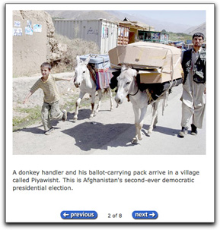  Slides: The 2009 Afghanistan election
Geology | 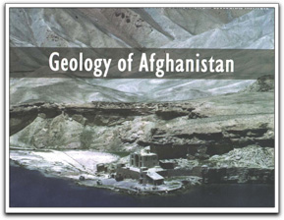  Slides: Geology in Afghanistan
Women's rights | 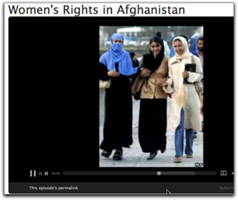  Women's rights in Afghanistan - videos
Music / Dance  Dance | 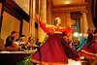  Image: Dance | 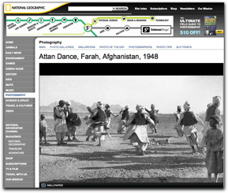  Men perform Attan dance, 1948 - National Geographic image
 | 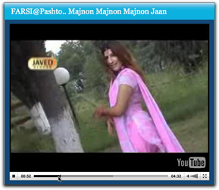  Afghan song and dance - You Tube video |  |  | 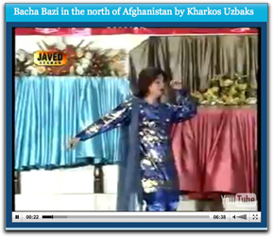  Bacha Bazi dance - You Tube video
Videos  General situation | 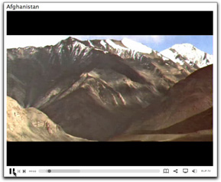  Basic intro to Afghanistan's problems - Blip TV movie
Education | 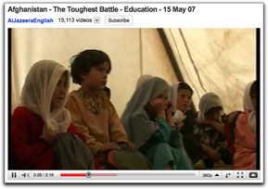  The toughest battle - You Tube video |  |  | 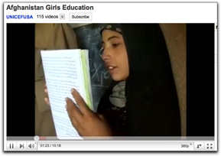  Rebuilding through education - You Tube video
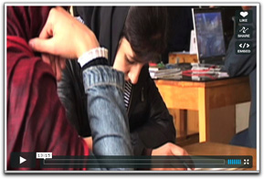
Rebuilding Afghanistan, one book at a time - Vimeo video
Readers, eBooks, comics, magazines, podcasts | 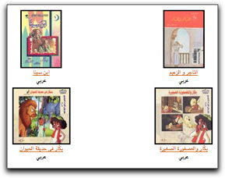  Children's books in Arabic  Children's radio programme – podcast  Photojournalist Reza - Charlie Devereux talks to world-renowned photojournalist Reza about his Kabul-based NGO Aïna and ambitions to construct a free Afghan media.  Afghanistan - an eBook by Hamilton, A. (Angus), 1874-1913  Afghanistan and the Anglo-Russian Dispute - eBook by Rodenbough, Theo. F.  An inquiry into the ethnography of Afghanistan (1977) - eBook by Bellew, H. W. (Henry Walter), 1834-1892
Newspapers |   Links to a range of newspapers about Afghanistan  Online Afghanistan newspapers - 12 online newspapers

